**DATABASE SYSTEMS- ASSIGNMNET 2- PART3**

**ARCHI SAHU 1002104548**

Question1 and Question2:

**INSERTING DATA, WRITING QUERIES and RETRIEVING THE OUTPUT**

Customer table:

Insert query:

Car table:

Insert query:

Trigger on cars table after inserting cars details:

Availability table:

Rental table:

Tigger before inserting data into rental table:

Insert query:

Tigger after inserting data into rental table:

Question3:

**Write a query that will prepare a report for weekly earnings by owner, by car type and per car unit that owner owns within that car type.**

Question4:

Write the following database update transactions using any suitable programming or scripting language (e.g. JAVA/JDBC, Python or PHP).

**4.1 The first transaction is to add information about a new CUSTOMER.**

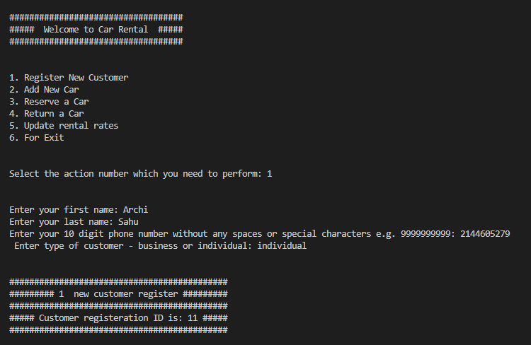

After executing this, you can find the updated data in the SQL as shown below.

**4.2 The second transaction is to add all the information about a new CAR.**

After executing this, you can find the updated data in the SQL as shown below.

**4.3 The third transaction is to add all the information about a new rental reservation (this must find a free car of the appropriate type for the rental period).**

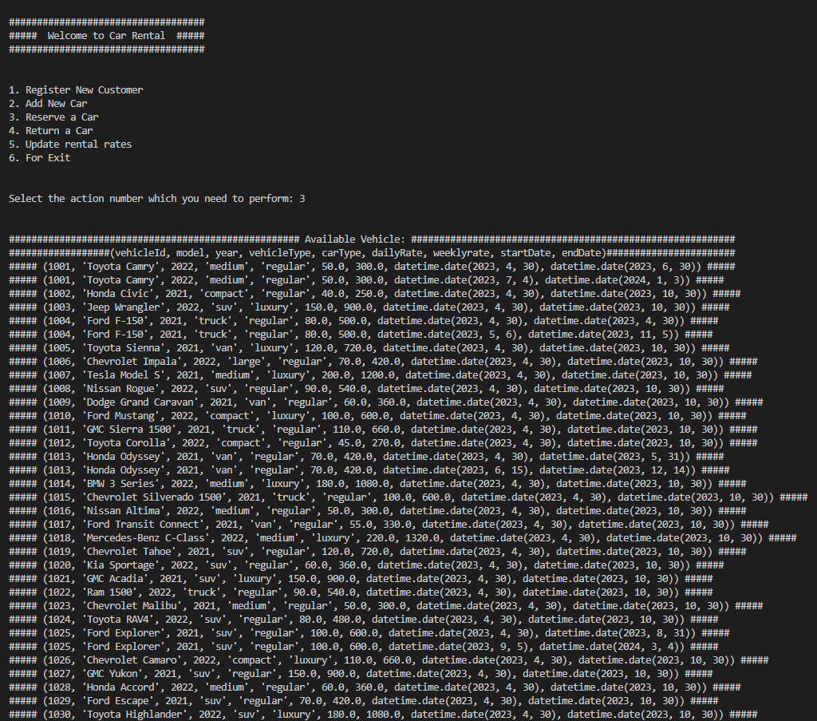

After executing this, you can find the updated data in the SQL as shown below.

**4.4 The fourth transaction is to handle the return of a rented car. This transaction should print the total customer payment due for the rental, and enter it in the database.**

Inserting AmountDue in rental table using trigger before_rental_insert.

**4.5 The fifth transaction is to enter or update the rental rates (daily and weekly) for a type of car.**

Updated daily rate:

After executing this, you can find the updated data in the SQL as shown below.

Update weekly rate:

After executing this, you can find the updated data in the SQL as shown below.

